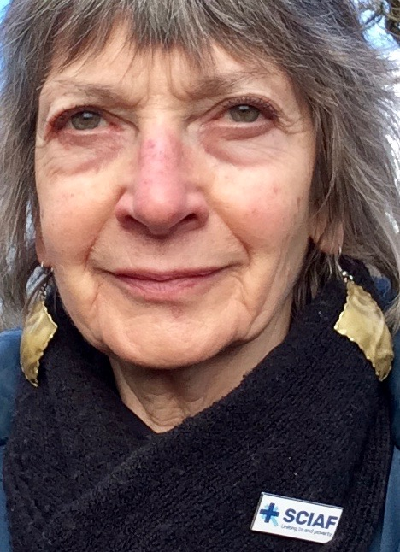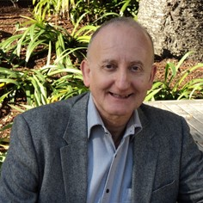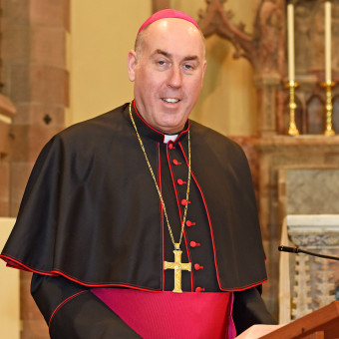

This Lent, SCIAF’s focus is on a generation of children with disabilities who are locked out of education and trapped in a cycle of poverty in South Sudan. These children were already the most vulnerable, and the coronavirus pandemic is deepening existing levels of poverty, putting them at greater risk.

South Sudan remains in serious crisis due to the effects of years of conflict and violence, which has left a legacy of fear and despair and has destroyed vital services.

Many children with disabilities in South Sudan can’t attend school or go on to work and earn a living. Many have no access to support services or hospitals for treatment and face stigma and discrimination.

SCIAF believes that every child, no matter where they are in the world, deserves a chance to live a full life. Together we can help children living in some of the world’s most difficult places to build bright futures.

**Join our Zoom event** to learn how the Catholic community in Scotland can help children with disabilities in South Sudan to access the education and support they need.

Marian Pallister

**You are invited to a Zoom meeting.**

**When: Mar 2, 2021 19:00 London time**

**Register in advance for this meeting:**

[**https://us02web.zoom.us/meeting/register/tZ0rdO2hpjkpG915TCa8QvhnykanK89qqkgO**](https://us02web.zoom.us/meeting/register/tZ0rdO2hpjkpG915TCa8QvhnykanK89qqkgO)

**After registering, you will receive a confirmation email containing information about joining the meeting.**

Our speakers:

* **Bishop Brian McGee**: Bishop of the Diocese of Argyll & the Isles and a SCIAF board member.
* **Marian Pallister:** SCIAF ambassador for the Diocese of Argyll and the Isles.
* **Dr Duncan MacLaren:** SCIAF’s first director; former Director of Programmes and then Secretary General of Caritas Internationalis; SCIAF board member 2014-2020.

# **7pm March 2, 2021 –**

# **SCIAF Lent Event**

# **in the**

# **Diocese of Argyll & the Isles**

Dr Duncan MacLaren

Bishop Brian McGee

SCIAF Argyll & the Isles